Cloud Data warehousing: Google BigQuery

1. BigQuery public datasets:
The Cloud Public Datasets Program catalog is in GCP Marketplace. You can find more details about each individual dataset by viewing the Marketplace pages in the Datasets section.
For example, we will be using the GDELT public dataset

Overview
The GDELT 2.0 Event Database is a global catalog of worldwide activities (“events”) in over 300 categories from protests and military attacks to peace appeals and diplomatic exchanges. Each event record details 58 fields capturing many different attributes of the event. The GDELT 2.0 Event Database currently runs from February 2015 to present, updated every 15 minutes and is comprised of 326 million mentions of 103 million distinct events as of February 19, 2016. This dataset uses machine translation coverage of all monitored content in 65 core languages, with a sample of an additional 35 languages hand translated. It also expands upon GDELT 1.0 by providing a separate MENTIONS table that records every mention of each event, along with the offset, context and confidence of each of those mentions.
Finding GDELT dataset in BigQuery:
- After creating a new project and enabling a billing account, Click on the navigation menu on the top left corner of the webpage.
- Click on Marketplace and Search for GDELT dataset.
- Select the GDELT 2.0 dataset and click on view dataset.
- The dataset will be added to your project and you can see the schemas on the bottom left of the screen under Resources.
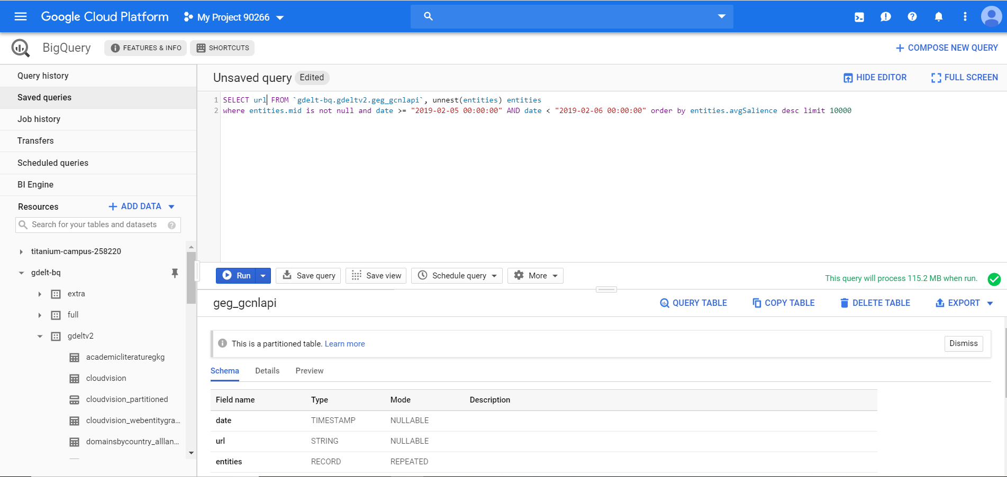
Calculating the cost of a query:
When you enter a query in the GCP Console, the query validator verifies the query syntax and provides an estimate of the number of bytes read. You can use this estimate to calculate query cost in the Pricing Calculator.
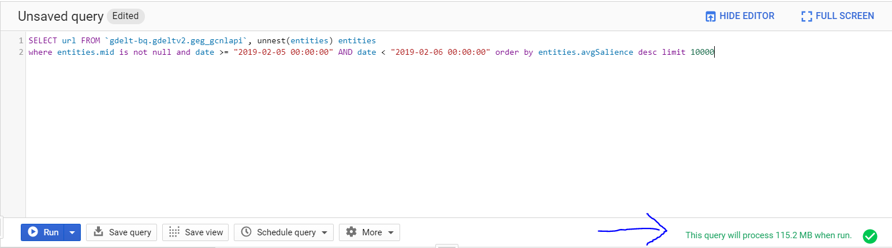
To estimate the cost of a query using the pricing calculator:
- Open the Google Cloud Platform Pricing Calculator,
- Click BigQuery.
- Click the On-Demand tab.
- For Table Name, type the name of the table. For example, table.
- For Storage Pricing, enter 0 in the Storage field.
- For Query Pricing, enter the estimated bytes read from your dry run or the query validator. For example, from the screenshot, the estimated bytes read is 115.2 MB.
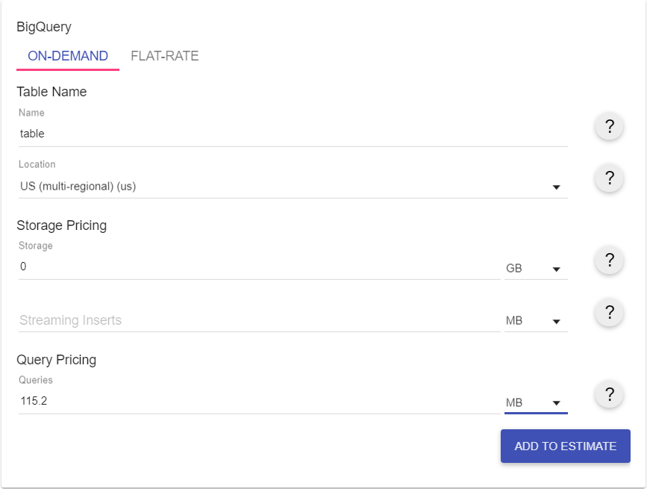
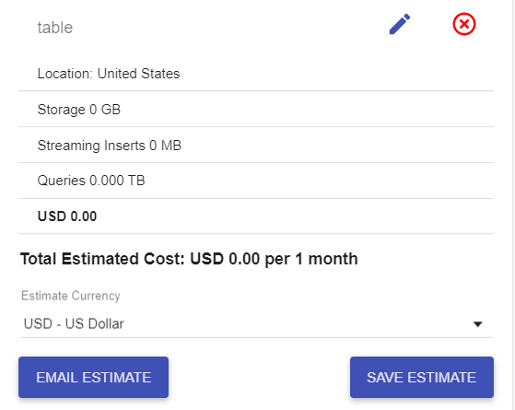
Running an example Query:
SELECT url FROM `gdelt-bq.gdeltv2.geg_gcnlapi`, unnest(entities) entities
where date >= "2019-02-05 00:00:00" AND date < "2019-02-06 00:00:00" order by entities.avgSalience desc limit 10000
Output:
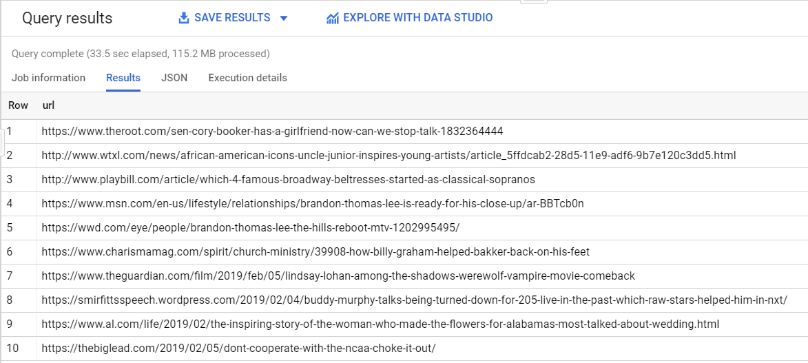
For more examples, refer: https://blog.gdeltproject.org/querying-the-new-global-entity-graph-geg-datasets-in-bigquery-example-queries/

2. New Project

To create a new project:

a. Go to the Manage resources page in the GCP Console.

b. On the Select organization drop-down list at the top of the page, select the organization in which you want to create a project. If you are a free trial user, skip this step, as this list does not appear.
c. Click Create Project.
d. In the New Project window that appears, enter a project name and select a billing account as applicable.
e. If you want to add the project to a folder, enter the folder name in the Location box.
f. When you're finished entering new project details, click Create.
For more info, https://cloud.google.com/resource-manager/docs/creating-managing-projects

CREATE TABLE customer_orders.customer
(
cust_id int64 not null,
cust_name string not null,
street string,
city string,
state string,
zip string

);

/* Creating the orders table */

CREATE TABLE customer_orders.orders(
order_id int64 not null ,
order_date date,
cust_id string
);

/* Creating the product table */

CREATE TABLE customer_orders.product(

product_id int64 NOT NULL,
product_name string,
product_price numeric
);

/*Create the OrderLine table */

CREATE TABLE customer_orders.orderLine
(
order_id int64 NOT NULL,
product_id int64 NOT NULL,
quantity int64
);

INSERT INTO customer_orders.customer(cust_id, cust_name, street, city, state,
zip) VALUES
(1, 'John Doe', '200 Maple', 'SLC', 'UT', '84102'),
(2, 'Bill Doll', '300 West', 'SLC', 'UT', '84107'),
(3, 'Josh Turburn', '250 North', 'SLC', 'UT', '84108'),
(4, 'Mary Lee', '200 South', 'SLC', 'UT', '84102'),
(5, 'Jane Smith', '120 University', 'SLC', 'UT', '84102'),
(6, 'Luis Smith', '200 Maple', 'SLC', 'UT', '84102'),
(7, 'Ben Brown', '300 West', 'SLC', 'UT', '84107'),
(8, 'Carl Smith', '250 North', 'SLC', 'UT', '84108'),
(9, 'John Doll', '200 South', 'SLC', 'UT', '84102'),
(10, 'Jennet Chris', '120 University', 'SLC', 'UT', '84102'),
(11, 'Joyce French', '200 Main', 'Tucson', 'AZ', '45102'),
(12, 'Jennifer English', '250 State', 'Tucson', 'AZ', '45112'),
(13, 'Tom Borg', '3000 Sunset', 'LA', 'CA', '12112'),
(14, 'Helen Thomas', '1200 Hollywood', 'LA', 'CA', '12117'),
(15, 'Brian Borg', '100 College', 'SF', 'CA', '17118');

select * from customer_orders.customer;

INSERT INTO customer_orders.product(product_id, product_name, product_price)
VALUES
(101, 'Dell E5300 Laptop', 489.98),
(102, 'Apple Laptop', 988.72),
(103, 'Printer', 59),
(104, 'Desk', 85.98),
(105, 'Office Chair', 55.99),
(106, 'Stapler', 15.88),
(107, 'Index Divider', 5.99),
(109, 'Shredder', 74.99);

INSERT INTO customer_orders.orders(order_id, order_date, cust_id)
VALUES
(1001, '2008-10-24', 1),
(1002, '2008-10-21', 8),
(1003, '2008-10-22', 15),
(1004, '2008-10-22', 5),
(1005, '2008-10-24', 3),
(1006, '2008-10-24', 2),
(1007, '2008-10-27', 11),
(1008, '2008-10-30', 12),
(1009, '2008-11-01', 4),
(1010, '2008-11-05', 1);

select* from customer_orders.orderLine;

SELECT product.product_name, count(product.product_name) as countfrequency
FROM customer_orders.product
WHERE product.product_id IN (
SELECT orderLine.product_id
FROM customer_orders.orderLine
GROUP BY orderLine.product_id
HAVING COUNT(*)>2)
GROUP BY product.product_name;

SELECT order_id, sum(product_price*quantity) AS total_cost_per_order
FROM customer_orders.orderLine, customer_orders.product
WHERE orderline.product_id = product.product_id
GROUP BY order_id;

3. Schema Auto-Detection using Big Query:
Schema auto-detection is available when you load data into BigQuery, and when you query an external data source.
When auto-detection is enabled, BigQuery starts the inference process by selecting a random file in the data source and scanning up to 100 rows of data to use as a representative sample. BigQuery then examines each field and attempts to assign a data type to that field based on the values in the sample.
To see the detected schema for a table:
- Use the command-line tool's bq show command
- Use the GCP Console or the classic web UI to view the table's schema
When BigQuery detects schemas, it might, on rare occasions, change a field name to make it compatible with BigQuery SQL syntax.
Loading data using schema auto-detection:
To enable schema auto-detection when loading data:
- GCP Console: In the Schema section, for Auto detect, check the Schema and input parameters option.
- Classic BigQuery web UI: In the Schema section, check the Automatically detect option.
- CLI: Use the bq load command with the --autodetect parameter.
When enabled, BigQuery makes a best-effort attempt to automatically infer the schema for CSV and JSON files.
Schema auto-detection is not used with Avro files, Parquet files, ORC files, Cloud Firestore export files, or Cloud Datastore export files. When you load these files into BigQuery, the table schema is automatically retrieved from the self-describing source data.
For more info https://cloud.google.com/bigquery/docs/schema-detect
Examine a table
BigQuery offers a number of sample tables that you can query. In this quickstart, you'll run some queries against the shakespeare table, which contains an entry for every word in every play.
To examine the schema of a specific table, run
bq show projectId:datasetId.tableId
where the project and dataset IDs can be omitted if they are the default values for your bq tool. The following example examines the shakespeare table in the samples dataset:
bq show bigquery-public-data:samples.shakespeare
Output:
Table bigquery-public-data:samples.shakespeare

Last modified Schema Total Rows Total Bytes Expiration
----------------- ------------------------------------ ------------ ------------- ------------
26 Aug 14:43:49 |- word: string (required) 164656 6432064
|- word_count: integer (required)
|- corpus: string (required)
|- corpus_date: integer (required)
For more info: https://cloud.google.com/bigquery/docs/quickstarts/quickstart-command-line

